Background
Provide a Clear Path
Remember that the goal of an Email signature line is to provide the reader with the most direct line of contact(s) back to the sender. We don’t want the recipient of our email to have to “guess” which number (cell, local office, corporate office, toll free, alternate, etc.) is the best to use. This is why our template only includes space for 2 numbers.

No Physical Address
This is an intentional design. 95% of the time an email recipient doesn’t need a physical address. In the event that they need it, this is an easy “ask”. We want the signature line to be as compact as possible so we are omitting the physical address.

The Basics
- Font: Arial, except for the legal statement which is Calibri.
- Complimentary Close: Can be customized to user’s preference (For Example: Best, Sincerely, Thank You, etc.).
- Contact Numbers: Choose 2 of the following:
  - Cell, use lower case “c” as identifier
  - Office, use lower case “o” as identifier
  - Fax, use lower case “f” as identifier
  - If only using one number no identifier is needed.
- Do not alter font, size, colors.
- Background of email should be white.
- Do not add personalized or other information to your signature line (For Example: quotes, taglines, logos, images, etc.)

Step By Step Instructions
- The Word document attached contains your new email signature with the Elara Caring logo; open that document
- Customize your name and information in the Word document. It is trickier to adjust this once it is pasted into Outlook.
- Highlight all text from appropriate signature line (beginning at “Best… and ending at ...received.”).

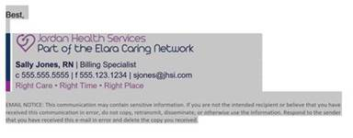

- Right Click and choose “Copy” or click “CTRL-C” on your keyboard.

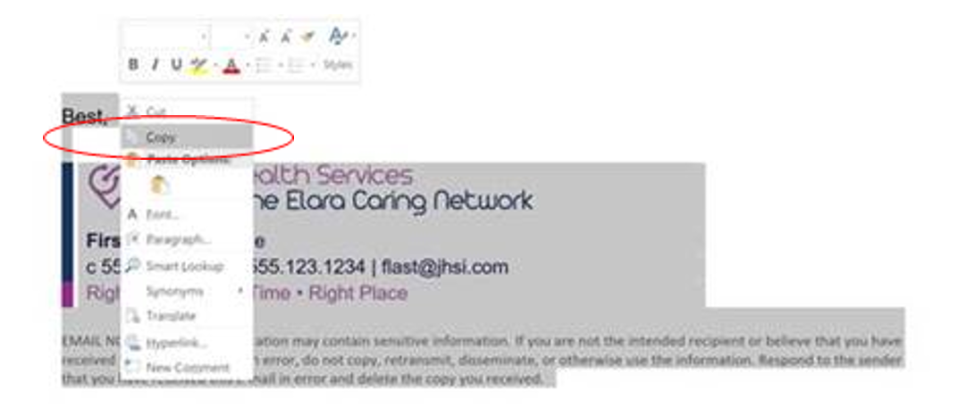

- Open your Outlook email. Click “New Mail”
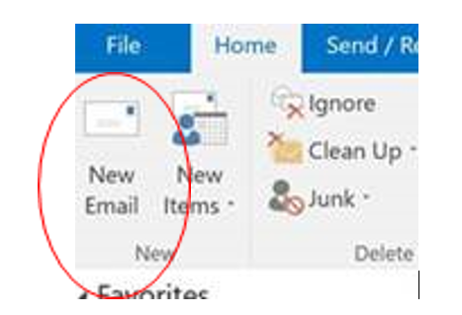

- Click Signature from the ribbon then choose “Signatures” from the drop down list.

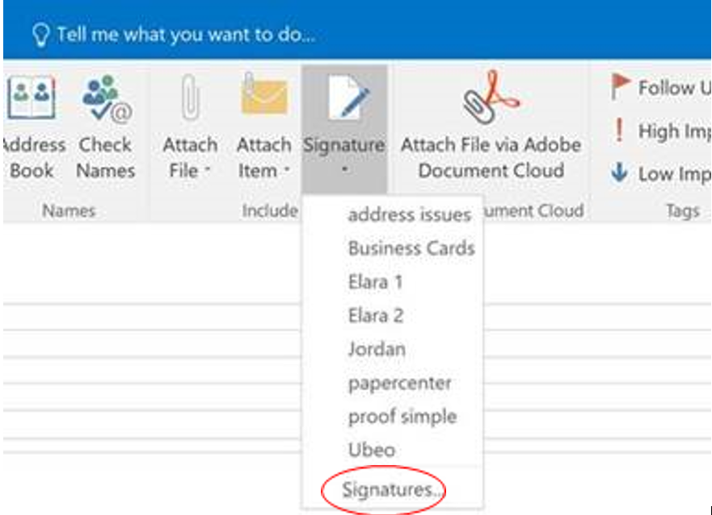

- Click “New”
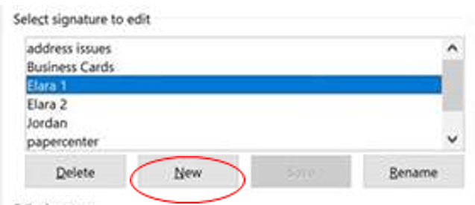

- Type in a name for the signature.
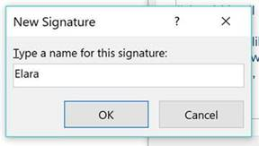

- Place your cursor in the text field.

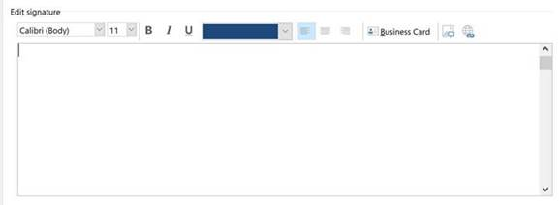

- To Paste: Right Click and Choose the image of the clipboard “Paste” or type “CTRL-V” on your keyboard.
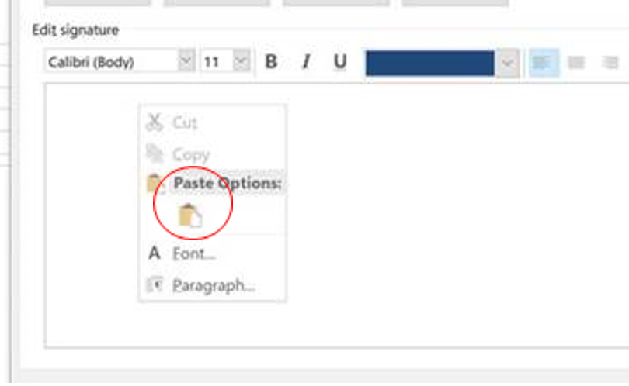

- Once the image is pasted in click “OK” at the bottom of the window.

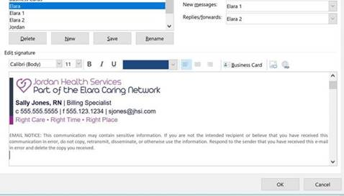

- Once you have saved the signature go back into the “Signatures” box and make sure that “New messages” and “Replies/forwards” contains the new signature you just created.
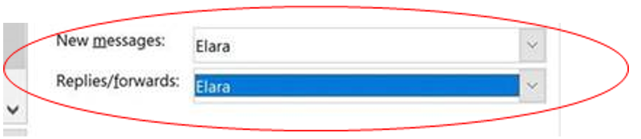

- If you get stuck, first reach out to a coworker who has their signature properly in place.
- If you’re all stuck, please contact the Helpdesk

